Bugs and Errors Report # 8

Project URL: <https://takingmyclassesonline.com/>

Effective Dated: 12th November 2024

URL # 1: <https://takingmyclassesonline.com/take-gmat-online-exam>

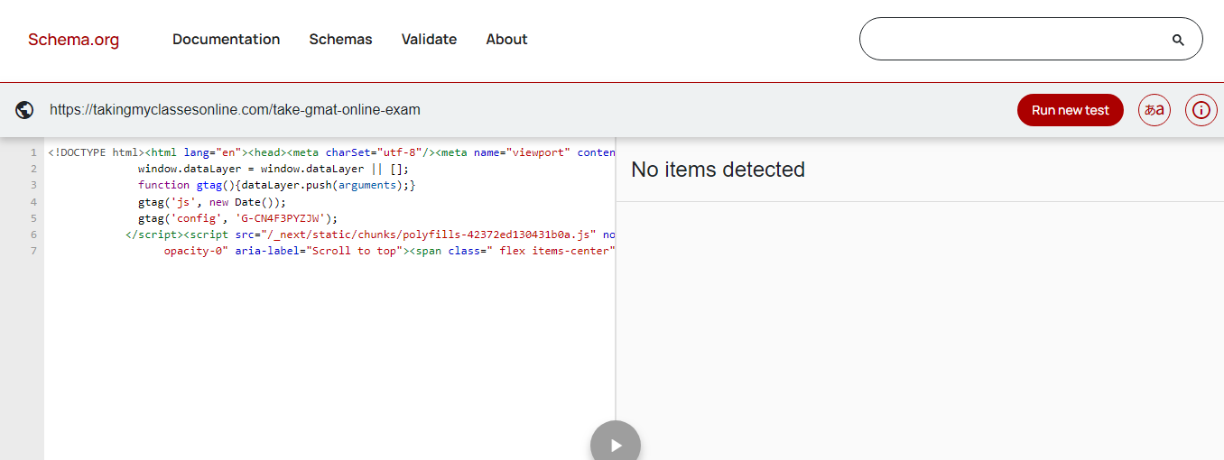

Note: Schema markup not validate.

URL # 2: <https://takingmyclassesonline.com/toefl-exam-online>

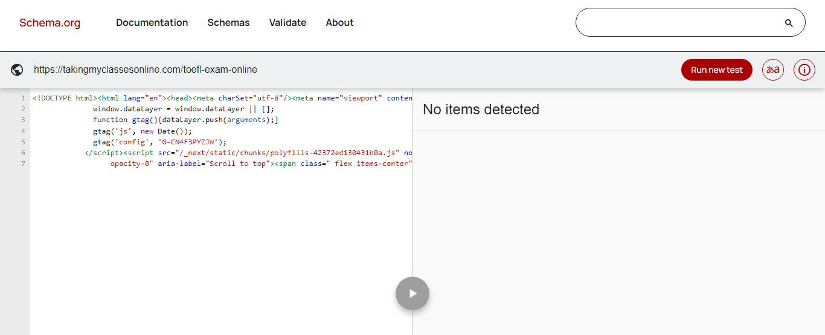

Note: Schema markup not validate.

URL # 3: https://takingmyclassesonline.com/hesi-exam

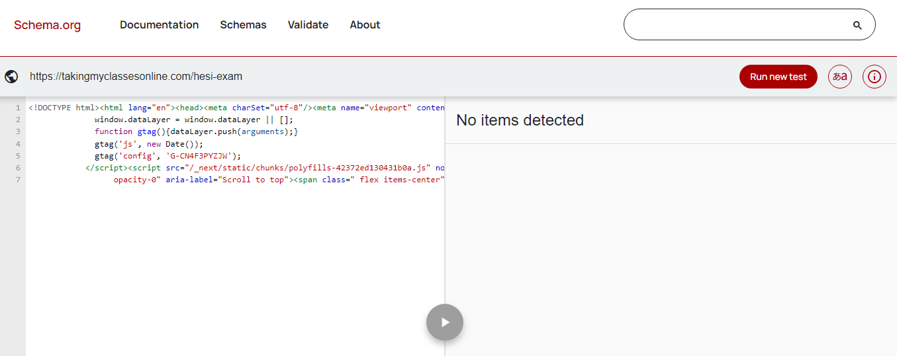

Note: Schema markup not validate.

URL # 3: <https://takingmyclassesonline.com/pte-academic-online>

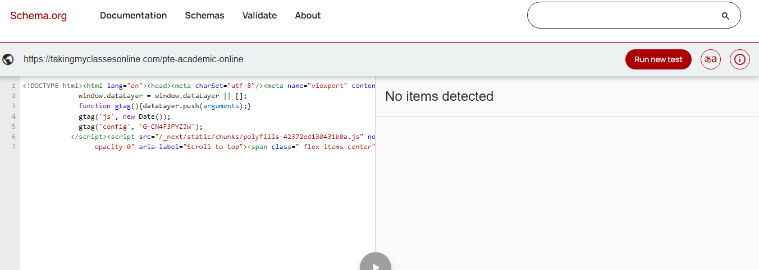

Note: Schema markup not validate.

URL # 4: <https://takingmyclassesonline.com/lsat-exam-prep>

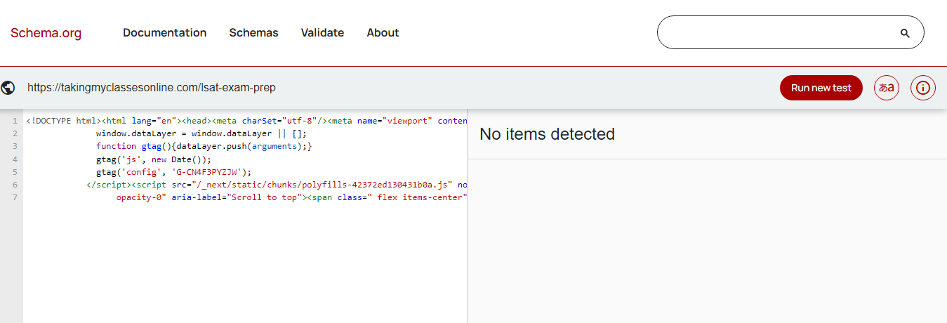

Note: Schema markup not validate.

URL # 5: <https://takingmyclassesonline.com/take-my-teas-exam-for-me>

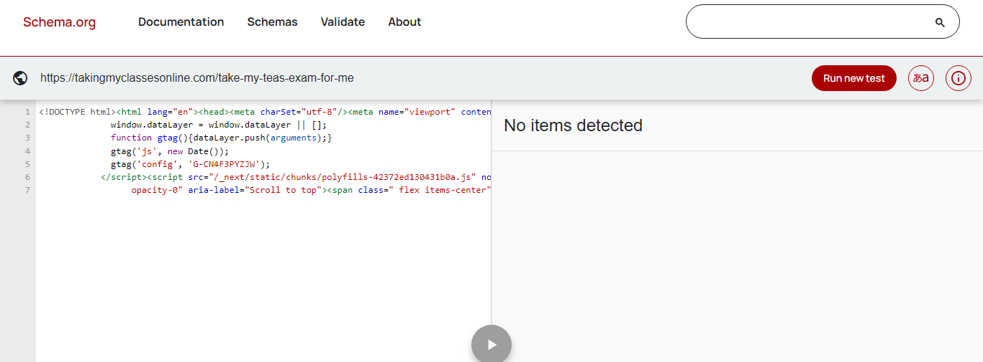

Note: Schema markup not validate.

URL # 6: <https://takingmyclassesonline.com/take-my-ged-for-me>

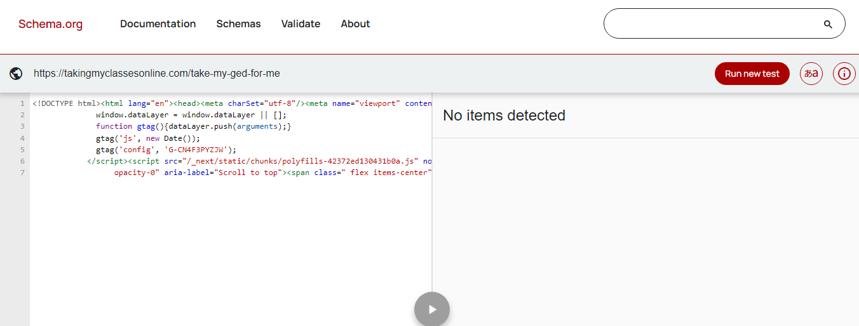

Note: Schema markup not validate.

URL # 7: <https://takingmyclassesonline.com/pay-someone-to-take-my-class>

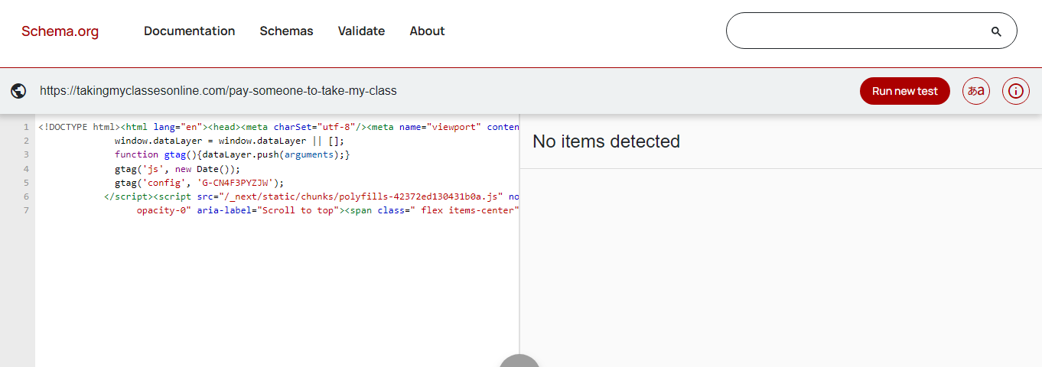

Note: Schema markup not validate.